Practical File
of
Fundamentals of C Programming
(24CSE0107)
Batch-2025
Bachelor of Engineering (CSE)



Submitted By  Hitain Singla  Roll No. - 2510990141  Group No G1, Sem: 2nd, BE (CSE)  Chitkara University, Punjab, 140401  India | Submitted To  Dr. Vibhu Sharma  Assistant Professor, CSE  Chitkara University, Punjab, 140401  India

Department of
Computer Science and Engineering,
Chitkara University School of Engineering and Technology,
Chitkara University, Punjab, India

Index
List of practical (Fundamentals of C Programming -24CSE0107)
S.  No. | Practical | Page  No.
 | Discussion on uploading and managing C Programming Lab Practical on GitHub using GitBash/CMD.
1. | Install C compiler (GCC/Code::Blocks), set up IDE, compile and run the first "Hello, World!" program. | 4-4
2. | Write a Program to show the use to input (Scanf)/output (Printf) statements and block structure of C-program by highlighting the features of "stdio.h". | 5-6
3. | Write a program to add two numbers and display the sum. | 7-8
4. | Write a program to calculate the area and the circumference of a circle by using radius as the input provided by the user. | 9-10
5. | Write a Program to perform addition, subtraction, division and multiplication of two numbers given as input by the user. | 11-12
6. | Write a program to evaluate each of the following equations.  (i) V = u + at. (ii) S = ut+1/2at² (iii) T=2*a+√b+9c (iv) H=√b²+p² | 13-14
7. | Write a program to swap two variables:  a) By using temporary variable.  b) Without using temporary variable | 15-17
8. | Write a Program to find the greatest among three numbers using:  - Conditional Operator  - If-Else statement | 18-20
9. | Write the following programs using switch case statement:  - To check that an input alphabet is vowel or consonant  - To check whether a number is positive, negative or zero | 21-23
10. | Write a program using while loop to print the sum of first n natural numbers. | 24-25
11. | Write a program to check a number is Armstrong or not using For loop.
12. | Write the program to count the digits in a number and then print the reverse of the number also.
13. | Write a program to generate the Fibonacci series.
14. | Write a program to print the following patterns:  a)  *  * *  * * *  * * * *  * * * * *  * * * * * *  b)  *  * *  * * *  * * * *  * * * * *  * * * * * *
15. | Write the program to print the following pattern:  1 2 3 4 5 6  2 4 6 8 10 12  3 6 9 12 15 18  4 8 12 16 20 24  5 10 15 20 25 30  6 12 18 24 30 36
16. | Write a program to check that the given number is prime, Armstrong or perfect using the concept of functions.
17. | Write a program to calculate the area and circumference of a circle using functions.
18. | Write a program to swap two variables using the concept of call by value and call by reference.
19. | Write a program to perform the following operations on 1D-Array:  - Insert  - Update  - Delete  - Display  - Search
20. | Write a program to calculate the sum of array elements by passing it to a function.
21. | Write a program to show the use of passing pointer as arguments to the functions.
22. | Write a program matrix multiplication using the concept of 2D array
23. | Write a program to transpose a given matrix.
24. | Write a program to find the factorial of a number by using the concept of recursion.
25. | Write a menu driven C program to show the use of in-built string functions like strlen, strcat, strcpy, strcmp, strrev etc.
26. | Write a Program in C to display the total number of appearances of a substring provided as input by the user in a given string.
27. | Write a program to display the sum of the digits of a number by using the concept of recursion.
28. | Write a C program to add two distances in inch & feet using the concept of structures.
29. | Write a C program to add two complex numbers using the concept of structures in C.
30. | Write a program in C to store the information of five employees using both concepts i.e. array of structure and array within structure.
31. | Write a Program in C to find and replace a specific string in a file and also display the total number of appearances of that string.

Experiment No. 1.
Aim: Install C compiler (GCC/Code::Blocks), set up IDE, compile and run the first "Hello, World!" program
Concept Used:
- C Programming Language Structure
- #include <stdio.h> → Used to include standard input-output library.
- main() → Entry point of a C program.
- printf() → Used to print output to the screen.
- return 0; → Indicates successful execution of the program.
- Compilation Process:
  - Source Code (.c file)
  - Compiler converts it into executable file
  - Executable file runs and produces output
Program:
#include <stdio.h>
int main() {
printf("Hello, World!");
return 0;
}
Output Screenshot:

Experiment No. 2.
Aim: Write a Program to show the use to input (Scanf)/output (Printf) statements and block structure of C-program by highlighting the features of "stdio.h".
Concept Used: 1. Header File – stdio.h
- stdio.h stands for Standard Input Output Header File.
- It contains declarations of input/output functions like:
  - printf() → Used to display output.
  - scanf() → Used to take input from user.
2. Block Structure of C Program
A C program consists of:
- Documentation section
- Link section (#include <stdio.h>)
- Global declaration section
- main() function
- Declaration part inside main()
- Executable part inside main()
3. Format Specifiers
- %d → Integer
- %f → Float
- %c → Character
- %s → String
Program:
#include <stdio.h>
int main()
{
int roll;
float marks;
char grade;
printf("Enter Roll Number: ");
scanf("%d", &roll);
printf("Enter Marks: ");
scanf("%f", &marks);
printf("Enter Grade: ");
scanf(" %c", &grade);
printf("\n----- Student Details -----\n");
printf("Roll Number: %d\n", roll);
printf("Marks: %.2f\n", marks);
printf("Grade: %c\n", grade);
return 0;
}
Output Screenshot:
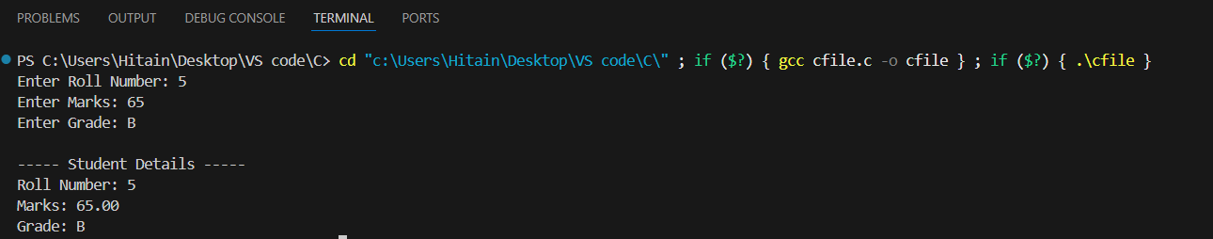

Experiment No. 3.
Aim: Write a program to add two numbers and display the sum.
Concept Used:
1. Variables
- Variables are used to store data.
- Example: int num1, num2, sum;
2. Data Type
- int data type is used to store integer values.
3. Input and Output Functions
- scanf() → Used to take input from the user.
- printf() → Used to display output.
4. Arithmetic Operator
- + operator is used to perform addition.
5. Header File
- #include <stdio.h> is used to include standard input-output functions.

Program:
#include <stdio.h>
int main()
{
int num1, num2, sum;
printf("Enter first number: ");
scanf("%d", &num1);
printf("Enter second number: ");
scanf("%d", &num2);
sum = num1 + num2;
printf("Sum of %d and %d is %d", num1, num2, sum);
return 0;
}

Output Screenshot:

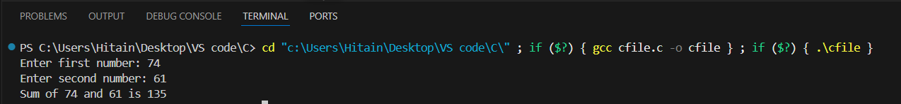

Experiment No. 4.
Aim: Write a program to calculate the area and the circumference of a circle by using radius as the input provided by the user.
Concept Used:
1. Variables and Data Types
- float data type is used to store decimal values.
- Variables used:
  - radius
  - area
  - circumference
2. Input and Output Functions
- scanf() → Used to take radius as input.
- printf() → Used to display area and circumference.
3. Arithmetic Operators
- * → Multiplication operator.
4. Mathematical Formula
- Area of Circle = π × r²
- Circumference of Circle = 2 × π × r
- Value of π (pi) is taken as 3.14
5. Header File
- #include <stdio.h> → Used for standard input and output functions.

Program:
#include <stdio.h>
int main()
{
float radius, area, circumference;
float pi = 3.14;

printf("Enter the radius of the circle: ");
scanf("%f", &radius);
area = pi * radius * radius;
circumference = 2 * pi * radius;
printf("\nArea of the circle = %.2f", area);
printf("\nCircumference of the circle = %.2f", circumference);
return 0;
}
Output Screenshot:

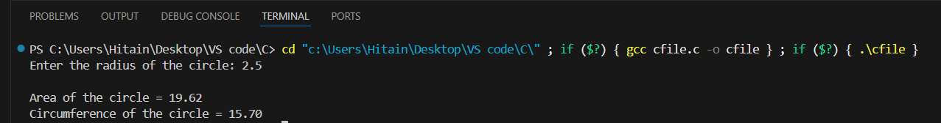

Experiment No. 5.
Aim: Write a Program to perform addition, subtraction, division and multiplication of two numbers given as input by the user.
Concept Used:
1. Variables and Data Types
- float data type is used to store numbers (to handle division properly).
- Variables used:
  - num1, num2
  - sum, difference, product, quotient
2. Input and Output Functions
- scanf() → Used to take input from the user.
- printf() → Used to display the results.
3. Arithmetic Operators
- + → Addition
- - → Subtraction
- * → Multiplication
- / → Division
4. Header File
- #include <stdio.h> → Used for standard input-output functions.
Program:
#include <stdio.h>
int main()
{
float num1, num2;
float sum, difference, product, quotient;
printf("Enter first number: ");
scanf("%f", &num1);
printf("Enter second number: ");
scanf("%f", &num2);
sum = num1 + num2;
difference = num1 - num2;
product = num1 * num2;
if (num2 != 0){
quotient = num1 / num2;
}
else
{
printf("\nDivision by zero is not possible.\n");
return 0;
}
printf("\nAddition = %.2f", sum);
printf("\nSubtraction = %.2f", difference);
printf("\nMultiplication = %.2f", product);
printf("\nDivision = %.2f", quotient);
return 0;
}
Output Screenshot:
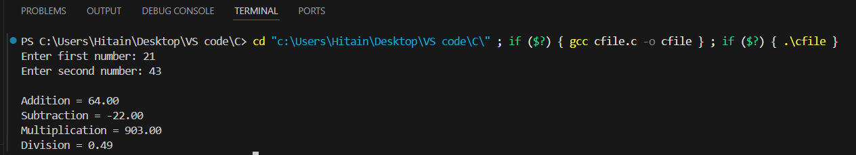
Experiment No. 6.
Aim: Write a program to evaluate each of the following equations.
(i) V = u + at. (ii) S = ut+1/2at² (iii) T=2*a+√b+9c (iv) H=√b²+p²
Concept Used:
1. Variables and Data Types
- float data type is used to store decimal values.
- Variables used:
  - u, a, t
  - V, S
  - b, c, T
  - p, H
2. Arithmetic Operators
- + → Addition
- * → Multiplication
- / → Division
3. Mathematical Functions
- sqrt() → Used to calculate square root.
- For using sqrt(), we include:
#include <math.h>
4. Header Files
- #include <stdio.h> → For input/output functions.
- #include <math.h> → For mathematical functions.

Program:
#include <stdio.h>
#include <math.h>
int main()
{
float u, a, t, V, S;
float b, c, T;
float p, H;
printf("Enter values of u, a, t: ");
scanf("%f %f %f", &u, &a, &t);
V = u + a * t;
S = u * t + 0.5 * a * t * t;
printf("\nV = %.2f", V);
printf("\nS = %.2f", S);
printf("\n\nEnter values of a, b, c: ");
scanf("%f %f %f", &a, &b, &c);
T = 2 * a + sqrt(b) + 9 * c;
printf("\nT = %.2f", T);
printf("\n\nEnter values of b and p: ");
scanf("%f %f", &b, &p);
H = sqrt(b * b + p * p);
printf("\nH = %.2f", H);
return 0;
}
Output Screenshot:
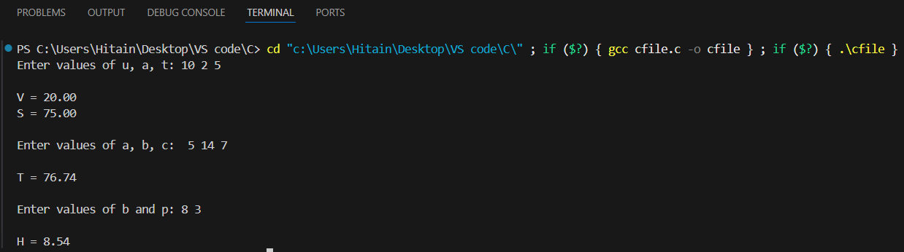

Experiment No. 7.
Aim: Write a program to swap two variables:
a) By using temporary variable.
b) Without using temporary variable
Concept Used:
1. Variables and Data Types
- int data type is used to store integer values.
- Variables used:
  - a, b
  - temp (temporary variable)
2. Swapping Concept
(a) Using Temporary Variable
- Store value of a in temp
- Assign value of b to a
- Assign value of temp to b
(b) Without Using Temporary Variable
- Use arithmetic operations:
  - a = a + b
  - b = a - b
  - a = a - b
3. Input and Output Functions
- scanf() → Used to take input.
- printf() → Used to display output.
4. Header File
- #include <stdio.h> → For standard input-output functions.

Program (a): Swapping Using Temporary Variable
#include <stdio.h>
int main()
{
int a, b, temp;
printf("Enter values of a and b: ");
scanf("%d %d", &a, &b);
temp = a;
a = b;
b = temp;
printf("\nAfter swapping:");
printf("\na = %d", a);
printf("\nb = %d", b);
return 0;
}
Output Screenshot:
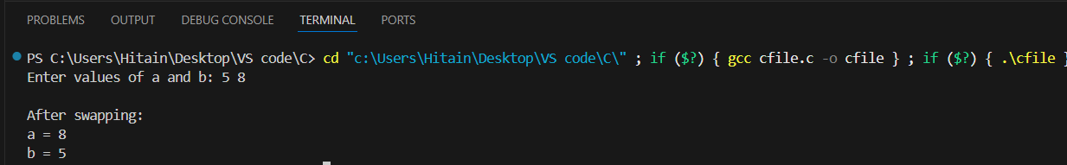

Program (b): Swapping Without Temporary Variable
#include <stdio.h>
int main()
{
int a, b;
printf("Enter values of a and b: ");
scanf("%d %d", &a, &b);
a = a + b;
b = a - b;
a = a - b;
printf("\nAfter swapping:");
printf("\na = %d", a);
printf("\nb = %d", b);

return 0;
}
Output Screenshot:
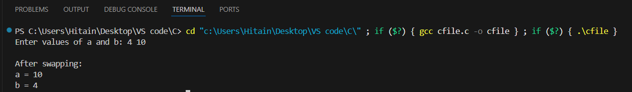

Experiment No. 8.
Aim: Write a Program to find the greatest among three numbers using:
- Conditional Operator
- If-Else statement
Concept Used:
1. Variables and Data Types
- int data type is used to store integer values.
- Variables used:
  - a, b, c
  - greatest
2. Conditional (Ternary) Operator
- Syntax:
condition ? expression1 : expression2;
- Used as a short form of if-else.
3. If–Else Statement
- Used to check conditions and execute statements accordingly.
- Syntax:
if(condition)
{
// statements
}
else
{
// statements
}
4. Relational Operators
- > → Greater than
- < → Less than
5. Header File
- #include <stdio.h> → For standard input-output functions.
Program (a): Using Conditional Operator
#include <stdio.h>
int main()
{
int a, b, c, greatest;
printf("Enter three numbers: ");
scanf("%d %d %d", &a, &b, &c);
greatest = (a > b) ?
((a > c) ? a : c) :
((b > c) ? b : c);
printf("Greatest number = %d", greatest);
return 0;
}
Output Screenshot:

Program (b): Using If–Else Statement
#include <stdio.h>
int main()
{
int a, b, c, greatest;
printf("Enter three numbers: ");
scanf("%d %d %d", &a, &b, &c);
if (a > b && a > c){
greatest = a;
}
else if (b > c){
greatest = b;
}
else{
greatest = c;
}
printf("Greatest number = %d", greatest);
return 0;
}
Output Screenshot:

Experiment No. 9.
Aim: Write the following programs using switch case statement:
- To check that an input alphabet is vowel or consonant
- To check whether a number is positive, negative or zero

Concept Used:
1. Switch Case Statement
- Used to select one of many code blocks to be executed.
- Syntax:
switch(expression)
{
case value1:
// statements
break;
case value2:
// statements
break;
default:
// statements
}
2. Break Statement
- Terminates a case block.
- Prevents fall-through to the next case.
3. Character and Integer Data Types
- char → Used for alphabet input.
- int → Used for numeric input.
4. Header File
- #include <stdio.h> → For input-output functions.

Program (a): Check Vowel or Consonant
#include <stdio.h>
int main()
{
char ch;
printf("Enter an alphabet: ");
scanf("%c", &ch);
switch(ch)
{
case 'a':
case 'e':
case 'i':
case 'o':
case 'u':
case 'A':
case 'E':
case 'I':
case 'O':
case 'U':
printf("It is a Vowel.");
break;
default:
printf("It is a Consonant.");
}
return 0;
}
Output Screenshot:
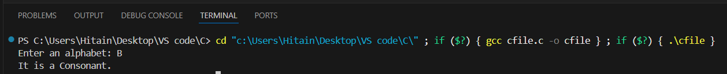

Program (b): Check Positive, Negative or Zero
#include <stdio.h>
int main()
{
int num;
printf("Enter a number: ");
scanf("%d", &num);
switch(num > 0)
{
case 1:
printf("Number is Positive.");
break;
case 0:
switch(num < 0)
{
case 1:
printf("Number is Negative.");
break;
default:
printf("Number is Zero.");
}
}
return 0;
}

Output Screenshot:

Experiment No. 10.
Aim: Write a program using while loop to print the sum of first n natural numbers.
Concept Used:
1. Looping Statement – While Loop
- A while loop is used to repeat a block of code as long as the condition is true.
- Syntax:
while(condition)
{
// statements
}
2. Natural Numbers
- Natural numbers start from 1.
- First n natural numbers:
1 + 2 + 3 + ... + n
3. Variables Used
- int n → Number of terms
- int i → Loop counter
- int sum → To store the total sum
4. Header File
- #include <stdio.h> → For input-output functions.

Program:
#include <stdio.h>
int main()
{
int n, i = 1, sum = 0;
printf("Enter a positive integer: ");
scanf("%d", &n);
while(i <= n)
{
sum = sum + i;
i++;
}
printf("Sum of first %d natural numbers = %d", n, sum);
return 0;
}
Output Screenshot:

